SMART SALE SYSTEM

*User’s Guide*

BY

RAFIUL ISLAM

171-35-1943

TAMIM IQBAL

171-35-1965 AND

JAHID HOSSAIN

171-35-2021

Department of SWE

Daffodil International University



### DAFFODIL INTERNATIONAL UNIVERSITY

DHAKA, BANGLADESH

DECEMBER12, 2018

©Daffodil International University

TABLE OF CONTENTS

PROJECT DECLARATION

I

AKNOWLEDGEMENT II

TABLE OF CONTENTS

III

USE CASE DIAGRAM IV

Requirement Engineering Process V

Setting up

Main

Functions

.....................................................................................................................................................................................................

##### 4

Preparations Required Before

Use

.....................................................................................................................................................................................................

##### 5

Preventing Unauthorized

Access

.....................................................................................................................................................................................................

##### 7

Setting Up Using the Setup

Guide

.....................................................................................................................................................................................................

##### 9

Setting the

Date/Time

.....................................................................................................................................................................................................

11

Setting Up the Network

Environment

..................................................................................................................................................................................................... 13

#### Basic Operations

Login

............................................................................................................................................................................................................

##### 14

Sing up

............................................................................................................................................................................................................

16 Create account

............................................................................................................................................................................................................

##### 18

New user

20

Log out

............................................................................................................................................................................................................

##### 22

About

............................................................................................................................................................................................................

23

## Entry information

Admin

............................................................................................................................................................................................................

##### 24

Customer

............................................................................................................................................................................................................

##### 26

Log out

Account

............................................................................................................................................................................................................

##### 36

## Admin

Sales person

............................................................................................................................................................................................................

##### 38

Customer info

............................................................................................................................................................................................................

##### 40

Supplier info

............................................................................................................................................................................................................

##### 42

Update all

............................................................................................................................................................................................................

##### 46

Over view

............................................................................................................................................................................................................

47

# Over view

Sale static

Customer review

48

## Customer

Home

Total product

Report

Log out

............................................................................................................................................................................................................

50

Totalproduct

Product name

Price Order logout

51

#### Setting Menu List

About

About……………………………………………………………………………………………………………………………………………

51

# LOG OUT ACCOUNT

User id and pssword……………………………………………………………………………………………………………………………52

### Use Case Modeling and Description

Use case model represents various types of users and their activities of a system. In this model are indicate the activities of admin, Salesman, Supplier, and customer.

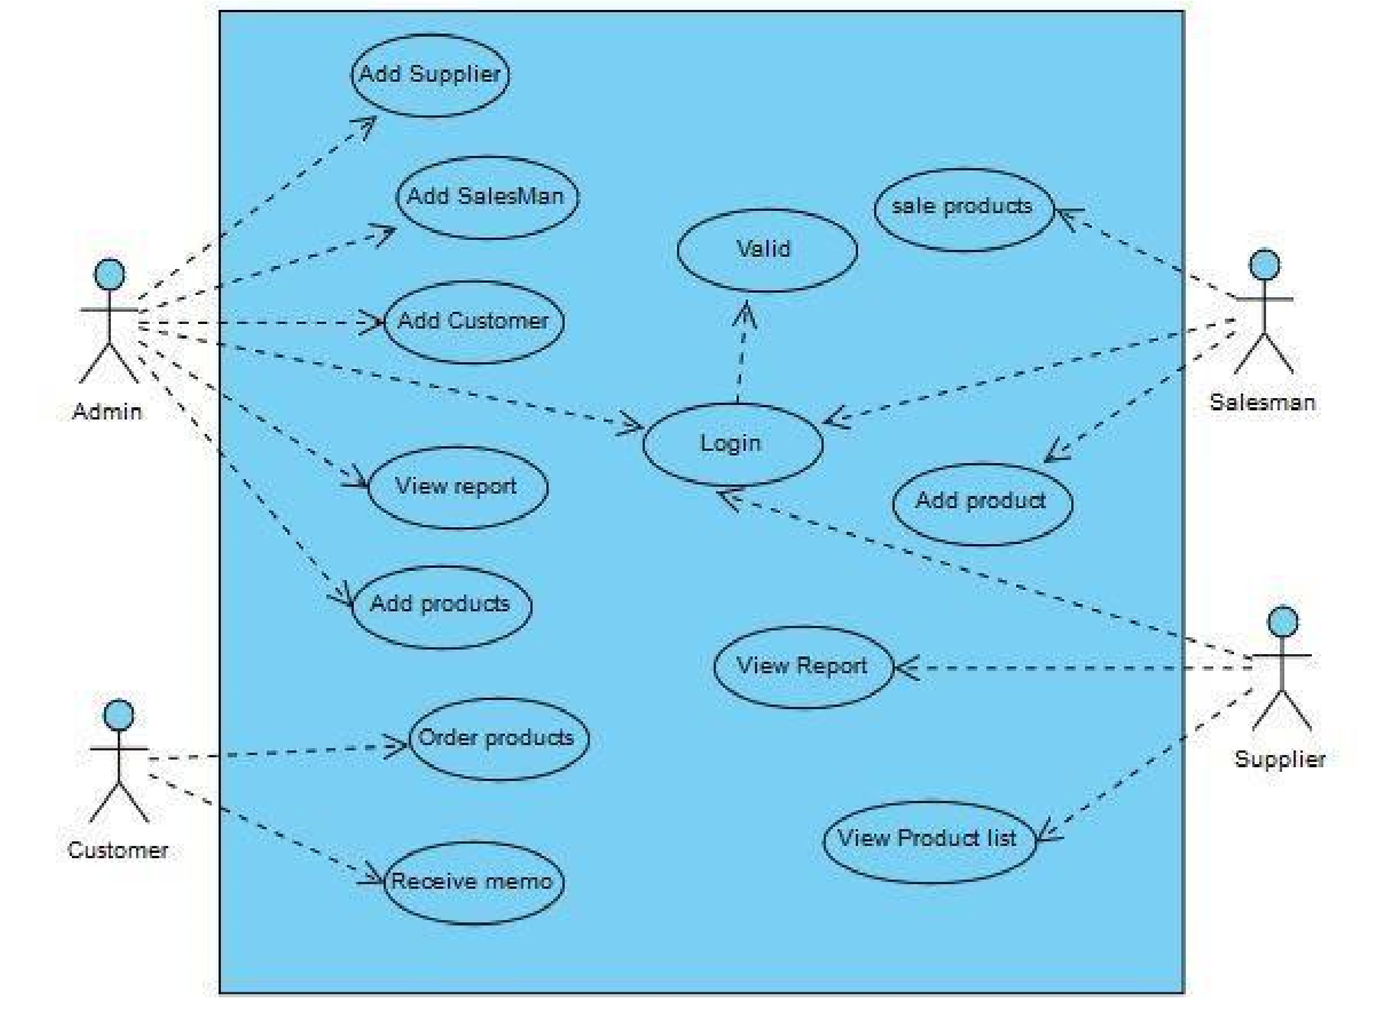

### Front-End Design

Usually front-end design consists of two parts: web design part and web development part. Frontend design includes creating the HTML, jQuery, CSS, and JavaScript that make up a user interface. Coding patterns are about placing a set of connections between elements. By codifying these connections as a set of policies instead of a single, stand-alone template, we make it feasible for other developers to extend our work while remaining faithful to its core ideas. This is visible while using a website is a compound of HTML, CSS, and JavaScript all being managed by a browser. Here added things like fonts, home, menus bar, buttons, sliders, contact forms of different types like login, logout, add, delete etc. Basically, we have used the PHP, Java-Script, HTML, CSS and Bootstrap to design the system. We will present the total process that we have used in our project

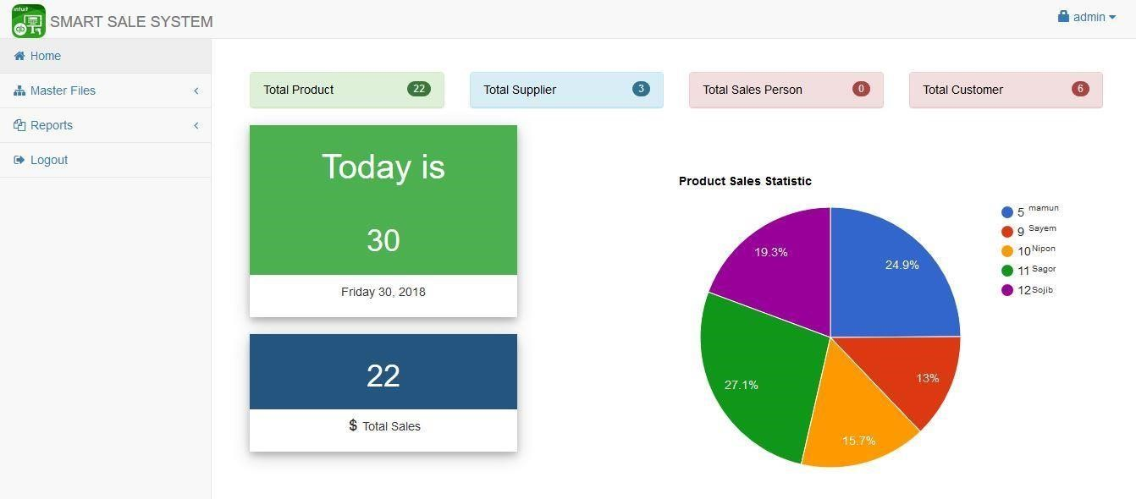

### Test Results and Reports

The report development is a main concern of our project. Firstly, our System is Sale oriented.

Each system needs an output as a result. As our testing report we have seen all expected results.

This statement is obviously important and time saving for the Organization.

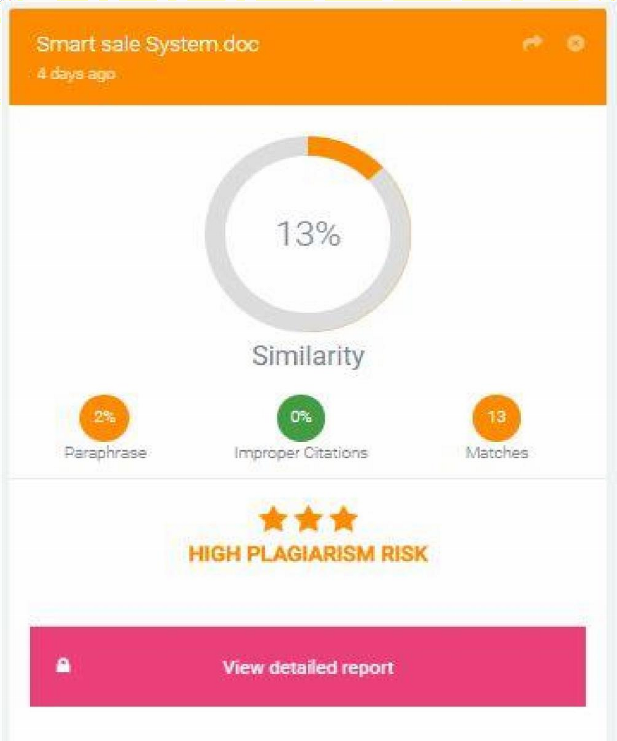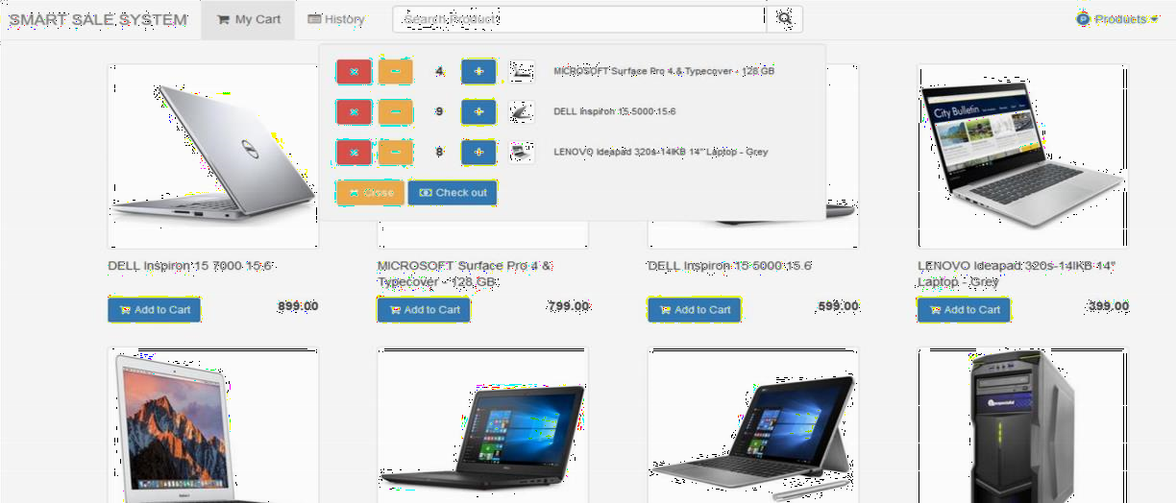

### Appendix B: Related Diagrams:

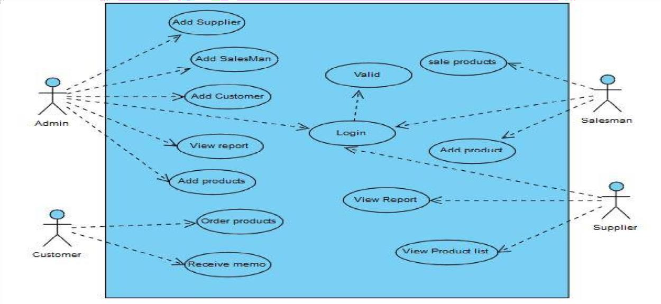

Over view:

